Experiment 1  
Name: Ansh Dhor CE1  
  
Aim: To check whether switch is ON or OFF of Street Light.  
  
Research:-We can use Light-Dependent Resistors (LDRs) and other sensors to detect ambient light levels, cameras to monitor the light's status and traffic, or even dedicated streetlight monitoring systems that use Internet of Things (IoT) technology to remotely control and report the on/off status of lights and send alerts for faults.  
Web: 1] https://www.ijraset.com/research-paper/automatic-street-light-on-and-off-using-ldr  
2]<https://www.researchgate.net/publication/375767152_Monitoring_Street_Light_Using_IoT_Technology_to_Detect_Fault_Automatically>  
  
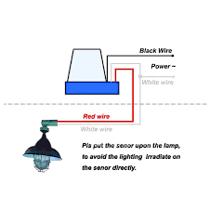  
  
Analysis:To determine if a street light switch is on or off, use a non-contact voltage tester by placing the tip near the switch; if the light is on and the switch is energized, the tester will indicate a reading (often a red light and sound). Physically observe the switch, as many have markings or symbols, or check the position (e.g., "up" for on, "down" for off). For a definitive test of a switch's state without touching live parts, power down the breaker and use a voltage tester to confirm no current is flowing.   
Ways by which we can reduce wastage of resources:-  
Method 1: Physical Observation  
Method 2: Using a Voltage Tester (Non-Contact)   
Method 3: Using a Multimeter (Advanced - Requires Safety Precautions)  
WEB: https://greenfrogsystems.com.au/solar-tips/how-does-the-street-light-system-work/  
  
Ideate:- :   
Technology Upgrades Smart design & Operation:  
\***Replace inefficient bulbs \*Automated dimming**  
\***Use solar power \*Daylight harvesting**  
\***Upgrade to electronic ballasts \*Optimize illumination levels**  
Intelligent Control Systems:  
\***Implement smart timers  
\*Install motion and infrared (IR) sensors  
\*Integrate with IoT**